Java Servlet Practical Lab Sheet

implement basic and advanced concepts of Java Servlets.

Steps:

1. Create a Java Servlet (DisplayMessageServlet) that outputs a static message.

2. Configure the servlet using the @WebServlet annotation or the web.xml deployment

descriptor.

**Code(index.html)**

<html>

<head>

<title>TODO supply a title</title>

<meta charset="UTF-8">

<meta name="viewport" content="width=device-width, initial-scale=1.0">

</head>

<body>

<div>TODO write content</div>

<form action="getUserInput" method="POST">

Name: <input type="text" name="username" required><br>

<input type="submit" value="Submit">

</form>

</body>

</html>

**(DisplayMessageServlet.html)**

import java.io.IOException;

import java.io.PrintWriter;

import javax.servlet.ServletException;

import javax.servlet.annotation.WebServlet;

import javax.servlet.http.HttpServlet;

import javax.servlet.http.HttpServletRequest;

import javax.servlet.http.HttpServletResponse;

/**

*

* @author student

*/

@WebServlet(urlPatterns = {"/DisplayMessageServlet"})

public class DisplayMessageServlet extends HttpServlet {

/**

* Processes requests for both HTTP <code>GET</code> and <code>POST</code>

* methods.

*

* @param request servlet request

* @param response servlet response

* @throws ServletException if a servlet-specific error occurs

* @throws IOException if an I/O error occurs

*/

protected void processRequest(HttpServletRequest request, HttpServletResponse response)

throws ServletException, IOException {

response.setContentType("text/html;charset=UTF-8");

try (PrintWriter out = response.getWriter()) {

/* TODO output your page here. You may use following sample code. */

out.println("<!DOCTYPE html>");

out.println("<html>");

out.println("<head>");

out.println("<title>Servlet DisplayMessageServlet</title>");

out.println("</head>");

out.println("<body>");

out.println("<h1>welcome to java lab !"+ request.getContextPath()+ "</h1>");

out.println("</body>");

out.println("</html>");

}

}

// <editor-fold defaultstate="collapsed" desc="HttpServlet methods. Click on the + sign on the left to edit the code.">

/**

* Handles the HTTP <code>GET</code> method.

*

* @param request servlet request

* @param response servlet response

* @throws ServletException if a servlet-specific error occurs

* @throws IOException if an I/O error occurs

*/

@Override

protected void doGet(HttpServletRequest request, HttpServletResponse response)

throws ServletException, IOException {

processRequest(request, response);

}

/**

* Handles the HTTP <code>POST</code> method.

*

* @param request servlet request

* @param response servlet response

* @throws ServletException if a servlet-specific error occurs

* @throws IOException if an I/O error occurs

*/

@Override

protected void doPost(HttpServletRequest request, HttpServletResponse response)

throws ServletException, IOException {

processRequest(request, response);

}

/**

* Returns a short description of the servlet.

*

* @return a String containing servlet description

*/

@Override

public String getServletInfo() {

return "Short description";

}// </editor-fold>

}

import java.io.IOException;

import java.io.PrintWriter;

import javax.servlet.ServletException;

import javax.servlet.annotation.WebServlet;

import javax.servlet.http.HttpServlet;

import javax.servlet.http.HttpServletRequest;

import javax.servlet.http.HttpServletResponse;

/**

*

* @author student

*/

@WebServlet(urlPatterns = {"/getUserInput"})

public class GetUserInputServlet extends HttpServlet {

/**

* Processes requests for both HTTP <code>GET</code> and <code>POST</code>

* methods.

*

* @param request servlet request

* @param response servlet response

* @throws ServletException if a servlet-specific error occurs

* @throws IOException if an I/O error occurs

*/

protected void processRequest(HttpServletRequest request, HttpServletResponse response)

throws ServletException, IOException {

response.setContentType("text/html;charset=UTF-8");

try (PrintWriter out = response.getWriter()) {

/* TODO output your page here. You may use following sample code. */

out.println("<!DOCTYPE html>");

out.println("<html>");

out.println("<head>");

out.println("<title>Servlet GetUserInputServlet</title>");

out.println("</head>");

out.println("<body>");

out.println("<h1>Servlet GetUserInputServlet at " + request.getContextPath() + "</h1>");

out.println("</body>");

out.println("</html>");

}

}

// <editor-fold defaultstate="collapsed" desc="HttpServlet methods. Click on the + sign on the left to edit the code.">

/**

* Handles the HTTP <code>GET</code> method.

*

* @param request servlet request

* @param response servlet response

* @throws ServletException if a servlet-specific error occurs

* @throws IOException if an I/O error occurs

*/

@Override

protected void doGet(HttpServletRequest request, HttpServletResponse response)

throws ServletException, IOException {

processRequest(request, response);

}

/**

* Handles the HTTP <code>POST</code> method.

*

* @param request servlet request

* @param response servlet response

* @throws ServletException if a servlet-specific error occurs

* @throws IOException if an I/O error occurs

*/

@Override

protected void doPost(HttpServletRequest request, HttpServletResponse response)

throws ServletException, IOException {

String username = request.getParameter("username");

response.setContentType("text/html");

PrintWriter out = response.getWriter();

out.println("<html><body>");

out.println("<h1>Hello, " + username + "!</h1>");

out.println("</body></html>");

processRequest(request, response);

}

/**

* Returns a short description of the servlet.

*

* @return a String containing servlet description

*/

@Override

public String getServletInfo() {

return "Short description";

}// </editor-fold>

} import java.io.IOException;

import java.io.PrintWriter;

import javax.servlet.ServletException;

import javax.servlet.annotation.WebServlet;

import javax.servlet.http.HttpServlet;

import javax.servlet.http.HttpServletRequest;

import javax.servlet.http.HttpServletResponse;

/**

*

* @author student

*/

@WebServlet(urlPatterns = {"/getUserInput"})

public class GetUserInputServlet extends HttpServlet {

/**

* Processes requests for both HTTP <code>GET</code> and <code>POST</code>

* methods.

*

* @param request servlet request

* @param response servlet response

* @throws ServletException if a servlet-specific error occurs

* @throws IOException if an I/O error occurs

*/

protected void processRequest(HttpServletRequest request, HttpServletResponse response)

throws ServletException, IOException {

response.setContentType("text/html;charset=UTF-8");

try (PrintWriter out = response.getWriter()) {

/* TODO output your page here. You may use following sample code. */

out.println("<!DOCTYPE html>");

out.println("<html>");

out.println("<head>");

out.println("<title>Servlet GetUserInputServlet</title>");

out.println("</head>");

out.println("<body>");

out.println("<h1>Servlet GetUserInputServlet at " + request.getContextPath() + "</h1>");

out.println("</body>");

out.println("</html>");

}

}

// <editor-fold defaultstate="collapsed" desc="HttpServlet methods. Click on the + sign on the left to edit the code.">

/**

* Handles the HTTP <code>GET</code> method.

*

* @param request servlet request

* @param response servlet response

* @throws ServletException if a servlet-specific error occurs

* @throws IOException if an I/O error occurs

*/

@Override

protected void doGet(HttpServletRequest request, HttpServletResponse response)

throws ServletException, IOException {

processRequest(request, response);

}

/**

* Handles the HTTP <code>POST</code> method.

*

* @param request servlet request

* @param response servlet response

* @throws ServletException if a servlet-specific error occurs

* @throws IOException if an I/O error occurs

*/

@Override

protected void doPost(HttpServletRequest request, HttpServletResponse response)

throws ServletException, IOException {

String username = request.getParameter("username");

response.setContentType("text/html");

PrintWriter out = response.getWriter();

out.println("<html><body>");

out.println("<h1>Hello, " + username + "!</h1>");

out.println("</body></html>");

processRequest(request, response);

}

/**

* Returns a short description of the servlet.

*

* @return a String containing servlet description

*/

@Override

public String getServletInfo() {

return "Short description";

}// </editor-fold>

} import java.io.IOException;

import java.io.PrintWriter;

import javax.servlet.ServletException;

import javax.servlet.annotation.WebServlet;

import javax.servlet.http.HttpServlet;

import javax.servlet.http.HttpServletRequest;

import javax.servlet.http.HttpServletResponse;

/**

*

* @author student

*/

@WebServlet(urlPatterns = {"/getUserInput"})

public class GetUserInputServlet extends HttpServlet {

/**

* Processes requests for both HTTP <code>GET</code> and <code>POST</code>

* methods.

*

* @param request servlet request

* @param response servlet response

* @throws ServletException if a servlet-specific error occurs

* @throws IOException if an I/O error occurs

*/

protected void processRequest(HttpServletRequest request, HttpServletResponse response)

throws ServletException, IOException {

response.setContentType("text/html;charset=UTF-8");

try (PrintWriter out = response.getWriter()) {

/* TODO output your page here. You may use following sample code. */

out.println("<!DOCTYPE html>");

out.println("<html>");

out.println("<head>");

out.println("<title>Servlet GetUserInputServlet</title>");

out.println("</head>");

out.println("<body>");

out.println("<h1>Servlet GetUserInputServlet at " + request.getContextPath() + "</h1>");

out.println("</body>");

out.println("</html>");

}

}

// <editor-fold defaultstate="collapsed" desc="HttpServlet methods. Click on the + sign on the left to edit the code.">

/**

* Handles the HTTP <code>GET</code> method.

*

* @param request servlet request

* @param response servlet response

* @throws ServletException if a servlet-specific error occurs

* @throws IOException if an I/O error occurs

*/

@Override

protected void doGet(HttpServletRequest request, HttpServletResponse response)

throws ServletException, IOException {

processRequest(request, response);

}

/**

* Handles the HTTP <code>POST</code> method.

*

* @param request servlet request

* @param response servlet response

* @throws ServletException if a servlet-specific error occurs

* @throws IOException if an I/O error occurs

*/

@Override

protected void doPost(HttpServletRequest request, HttpServletResponse response)

throws ServletException, IOException {

String username = request.getParameter("username");

response.setContentType("text/html");

PrintWriter out = response.getWriter();

out.println("<html><body>");

out.println("<h1>Hello, " + username + "!</h1>");

out.println("</body></html>");

processRequest(request, response);

}

/**

* Returns a short description of the servlet.

*

* @return a String containing servlet description

*/

@Override

public String getServletInfo() {

return "Short description";

}// </editor-fold>

}

**(GetUserInput.Java)**

import java.io.IOException;

import java.io.PrintWriter;

import javax.servlet.ServletException;

import javax.servlet.annotation.WebServlet;

import javax.servlet.http.HttpServlet;

import javax.servlet.http.HttpServletRequest;

import javax.servlet.http.HttpServletResponse;

/**

*

* @author student

*/

@WebServlet(urlPatterns = {"/getUserInput"})

public class GetUserInputServlet extends HttpServlet {

/**

* Processes requests for both HTTP <code>GET</code> and <code>POST</code>

* methods.

*

* @param request servlet request

* @param response servlet response

* @throws ServletException if a servlet-specific error occurs

* @throws IOException if an I/O error occurs

*/

protected void processRequest(HttpServletRequest request, HttpServletResponse response)

throws ServletException, IOException {

response.setContentType("text/html;charset=UTF-8");

try (PrintWriter out = response.getWriter()) {

/* TODO output your page here. You may use following sample code. */

out.println("<!DOCTYPE html>");

out.println("<html>");

out.println("<head>");

out.println("<title>Servlet GetUserInputServlet</title>");

out.println("</head>");

out.println("<body>");

out.println("<h1>Servlet GetUserInputServlet at " + request.getContextPath() + "</h1>");

out.println("</body>");

out.println("</html>");

}

}

// <editor-fold defaultstate="collapsed" desc="HttpServlet methods. Click on the + sign on the left to edit the code.">

/**

* Handles the HTTP <code>GET</code> method.

*

* @param request servlet request

* @param response servlet response

* @throws ServletException if a servlet-specific error occurs

* @throws IOException if an I/O error occurs

*/

@Override

protected void doGet(HttpServletRequest request, HttpServletResponse response)

throws ServletException, IOException {

processRequest(request, response);

}

/**

* Handles the HTTP <code>POST</code> method.

*

* @param request servlet request

* @param response servlet response

* @throws ServletException if a servlet-specific error occurs

* @throws IOException if an I/O error occurs

*/

@Override

protected void doPost(HttpServletRequest request, HttpServletResponse response)

throws ServletException, IOException {

String username = request.getParameter("username");

response.setContentType("text/html");

PrintWriter out = response.getWriter();

out.println("<html><body>");

out.println("<h1>Hello, " + username + "!</h1>");

out.println("</body></html>");

processRequest(request, response);

}

/**

* Returns a short description of the servlet.

*

* @return a String containing servlet description

*/

@Override

public String getServletInfo() {

return "Short description";

}// </editor-fold>

}

INPUT

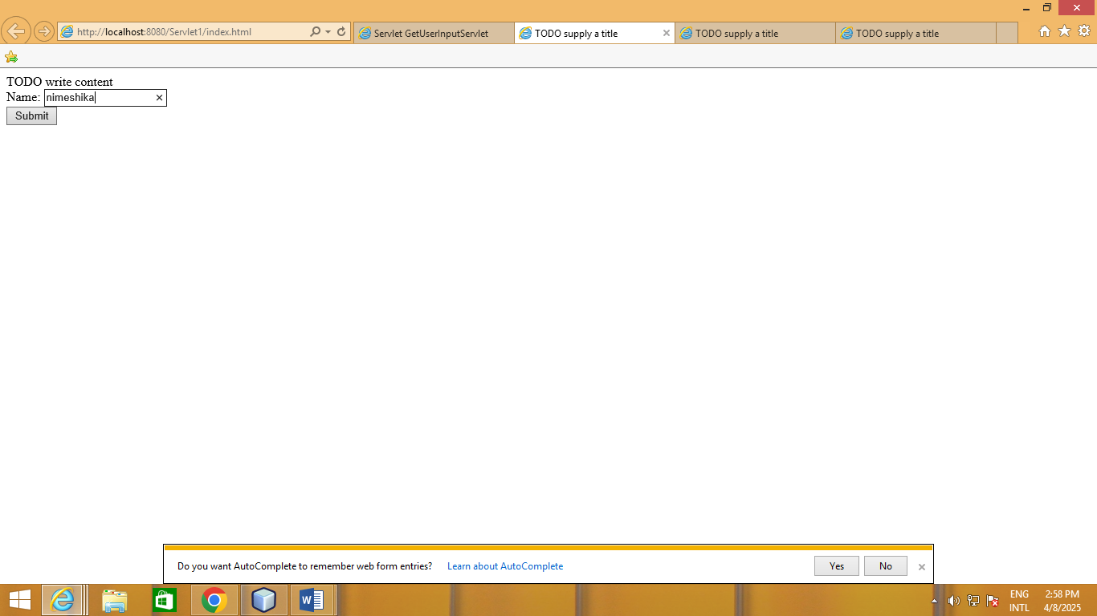

OUTPUT

